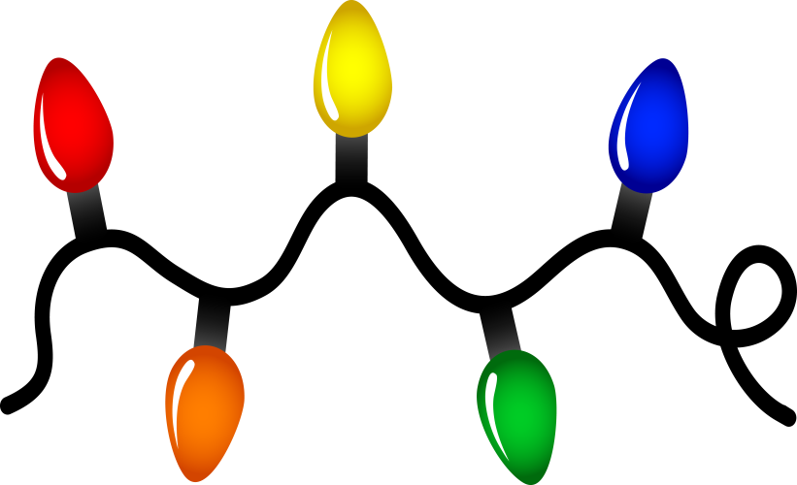

 Pre-K News Dec. 13, 2019

Dec. 13

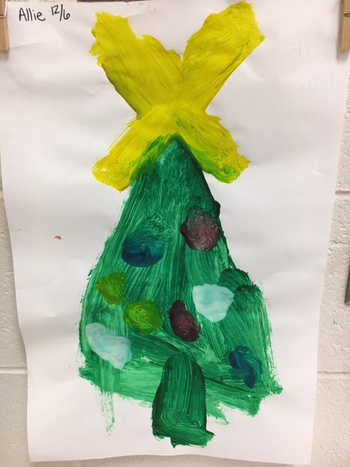

This week we sang Holiday songs and read stories including *Santa Duck, Five Little Candles, The Very Snowy Christmas, and The Puppy Who Wanted a Boy.* We drew pictures of presents and told what we wanted Santa to bring us! In the art center, we have been like Santa’s little elves making crafts and ornaments! We made peppermint bark on Friday to share with our families. We learned a rhyme that changed the color of Rudolph’s nose on every line! We practiced our number recognition and counting when we helped hang a string of lights on the board. We made 2 giant candy canes! We cut out the rectangles and learned a pattern poem to go with it. We are continuing to work on our social/emotional development, writing skills and letter recognition with activities throughout the day. Thank you to everyone who signed up for a conference and/or signed up to help with goodies for our party. Didn’t see an email? Check your spam or send me a remind message.

Have a great weekend!

Ms. Meredith &

Miss. Kelsie

**8.17.12**



**Reminders/Upcoming Events**

* **Wednesday, December 18th**

*An unwrapped, gently used book. *Goodies you signed up to send for our party.

* **Thursday, December 19th** Holiday Party 12:30
* **Friday, December 20th** School-Wide Polar Express and Pajama Day- **Wear your pajamas to school!**
* **Dec. 23- Jan 2-** Holiday Break- NO SCHOOL

**meredith.armistead@cowetaschools.net**