C:\Users\meredith\AppData\Local\Microsoft\Windows\Temporary Internet Files\Content.IE5\CSQL158X\MC900232107[1].wmf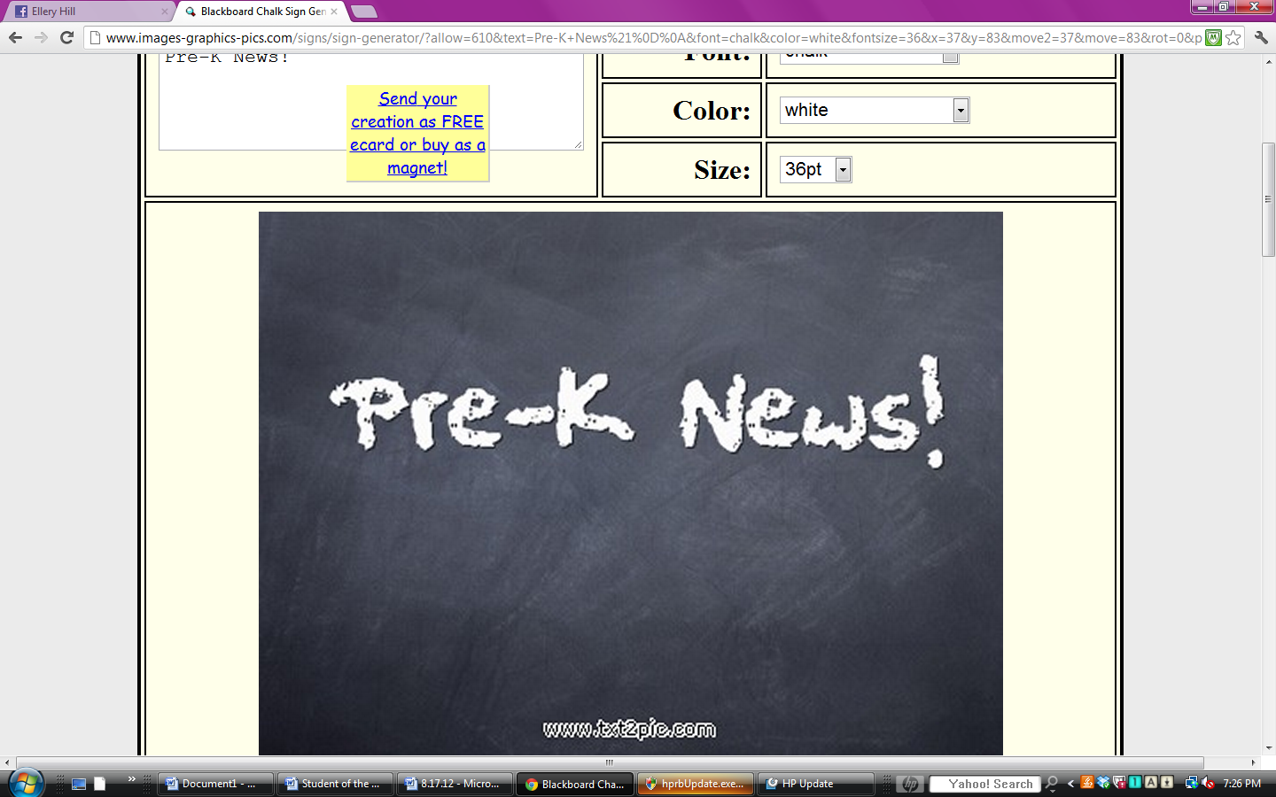

Ms. Meredith &

Miss Kelsie



This week we celebrated reading! The children enjoyed bringing books from home to share during storytime. We also read several Dr. Seuss books and will continue reading more of them next week. We talked about real and make believe and showed the children a picture of the real “Dr. Seuss” when he was a young man and a very old man. We made Seuss hats and the kiddos LOVED going to the reading caves in the library with our book buddies!

During large group time we practiced our rhyming, shapes, opposites, letters and counting as we moved around, sang songs, and had discussions.

For small group, we worked on positional words while building with different shapes and built “Seuss’ Silly Structures” using only tin foil.

*End of Year Program

Thursday, May 14th 8:30

*Field Day

Friday, May 15th 8:15-10:15

Have an great weekend!

**March 6, 2020**

**8.17.12**

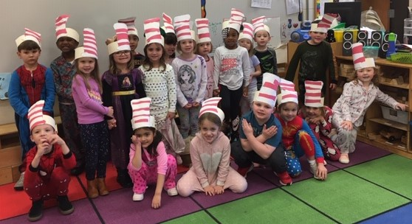

C:\Users\Meredith.corrigan\AppData\Local\Microsoft\Windows\Temporary Internet Files\Content.IE5\5M7I26Z6\MC900098151[1].wmf

ASES Spring Fling~Family Game Night

March 27, 2020

A special request and reminder in lieu of class baskets and working booths, this year we are in need of cash/check donations for prizes that will be awarded at Family Game Night. We need your Help!! Thank you for all your support to our ASE Gator Tribe!!!

We appreciate you!

Rosie Chevalier-Lemke, PTA Secretary

**meredith.armistead@cowetaschools.net**