C:\Users\Meredith.corrigan\AppData\Local\Microsoft\Windows\Temporary Internet Files\Content.IE5\H5JSPR4Y\MC900411087[1].wmf

Hello Families!

This week we began learning about Thanksgiving. We are teaching the children about being thankful for their families and for EVERYTHING they have! We are reading stories and discussing the Pilgrims, Indians, Plymouth Rock, and the Mayflower. We are singing songs, learning poems, and creating artwork that are all about turkeys and Thanksgiving. We are practicing letter recognition with a “*turkey letter match”* game, practicing our positional words with a *“turkeys on the barn”* game, we worked on the spelling of our names with a turkey stamping activity, and we played “*pin the feather on the turkey”* during large group time to help us with our number recognition.

We had a great time on our field trip last week to The Centre to see the Very Hungry Caterpillar and other Eric Carle stories. It went along well with our theme of eating healthy and Thanksgiving feasts!

Our school collects canned and non-perishable food items for the needy during November. If you can help out, please send in your items by the 20th. The grade level with the most items wins a prize!!

Keep an eye out for information about our Pre-K Christmas program. We hope you will all be able to attend.

Have a great weekend!

Ms. Meredith & Miss Kelsie

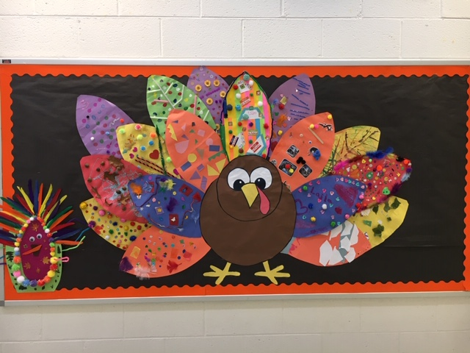

Our Thanksgiving turkey looks GREAT!!

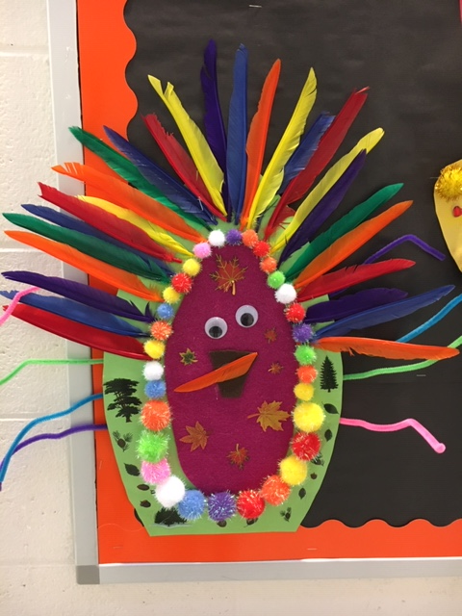 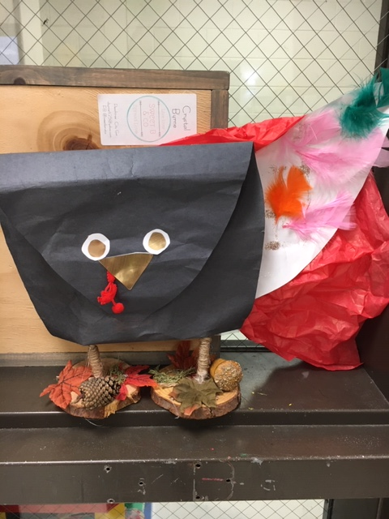

Cute Turkeys!!

***Nov. 15, 2019***

***Pre-K News***

***Ms. Meredith***

***& Miss Kelsie***

t ch

**Dates to Remember**

*Nov. 25th-29th Thanksgiving Holiday

*Dec. 10-13 (one of these days/ 8:30am)

Pre-K holiday program. I will pick a date soon!!

*Dec 20th last day before Christmas break