We hope everyone has a Happy Thanksgiving!
See you back on Monday, Dec. 2nd.

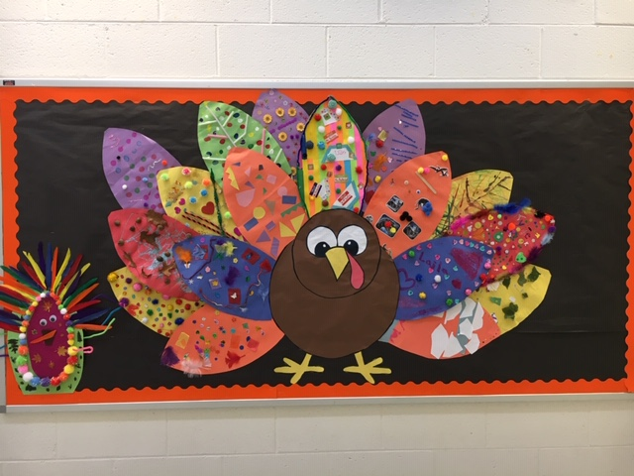

We are thankful for:

