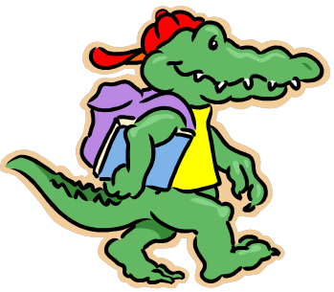

Our new writing center “the office” has been a big hit with the phones, keyboards and office supplies.

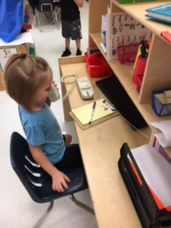

Re-Telling *The Three Little Pigs*!

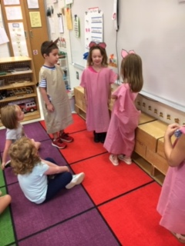

We have finished up our All About Me unit and are beginning to learn about Fall and Farm. The children have really enjoyed sharing their family photo pages with the class. If you haven’t sent yours in, please do so as soon as you can. We want everyone to be included 😊. We are also finishing up an *All About Me* book that will come home soon!

During large group time, we are reading books about the season of fall and all things farm. We are practicing writing strokes with games and songs. We played listening and guessing games and dressed up to re-tell the story *The Three Little Pigs*.

We have been practicing our fine motor skills with screws and knobs, cutting, and math manipulatives. Building the muscles in our hands and fingers will improve our writing skills tremendously. Be sure to incorporate activities such as playdoh, moving small objects from plate to plate and cutting at home!

During small group time we worked on recognizing the ABC’s (upper and lowercase) with letter magnets and practiced counting and number recognition. We also played sorting and patterning games and worked on our fine motor skills with tiny legos.

Have a great weekend!

Ms. Meredith & Miss Kelsie

*www.asesprek.weebly.com*

*meredith.armistead@cowetaschools.net*

**Oct. 4, 2019**

Pre-K News

Ms. Meredith

& Miss Kelsie

t ch

***Don’t Forget***

Oct 11th- 14th Fall Break

Oct 24th Family Fun Night! Come and trick-or-treat

at school (more info to come).