Day to Day in Pre-K
with Ms. Meredith & Miss. Kelsie
September 13, 2019

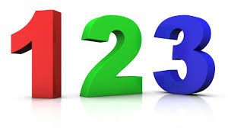
Math, Manipulatives, and Fine Motor Skills (hands & fingers)
We practiced our math concepts by sorting, putting together puzzles & counting. We have been counting lots of things like words in the morning message, fingers as we learn counting poems (One Two Buckle My Shoe), and how many friends are at school each day. We are developing our fine motor skills by lacing shapes, cutting, playing with playdoh and singing “Where is Thumbkin” (a song using our fingers).

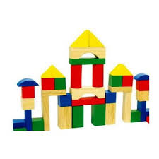
Blocks
We are learning to work together to build and clean up in the block center. We are learning how to be safe by only building structures as high as our chin and by not holding any big block items above our heads.

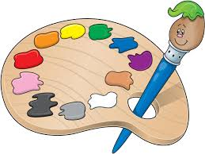
Art
We are introducing many of the materials and water color paints. Easel painting will be introduced next week. We have colored with markers and chalk, practiced with the scissors and made collage art with lots of glue! We are working on using our language skills to tell Ms. Meredith & Miss Kelsie about our artwork.

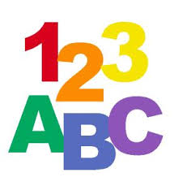
Language and Literacy
We listened to stories and have been singing songs to learn ALL ABOUT ME. We sorted pictures for “Our 5 Senses” chart. We are learning the poems Humpty Dumpty, Jack and Jill, and One Two Buckle My Shoe and repeating rhyming words. We are being introduced to letters, numbers, and shapes through small group activities, songs, and Mimio Board activities. Everyone is learning and/or practicing their writing strokes (pull down, push across, curve around, slant) using sand trays and dry erase boards and markers.

Music
We are singing songs like Where is Thumbkin?, Tootie Ta, I’ve Got Five Senses, The Body Rock and lots more. We danced with the scarves, paper plates, and played with the musical instruments.

Gator Run was a BIG success! Thanks to everyone for the pledges and for volunteering to help at this schoolwide event.

Ice Cream Fridays $1.00

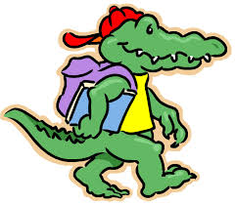

Wear your Arbor Springs Gator Shirt every Friday and show your school spirit!

Have a GREAT weekend!
Ms. Meredith & Miss Kelsie

